TITLE: HYBRID SECURITY FRAMEWORK INTEGRATING FIREWALL AND VPN TECHNOLOGIES

ABSTRACT

In the era of rapidly evolving cyber threats, organizations and individuals face challenges in maintaining secure and private network communications. Traditional security mechanisms such as firewalls and VPNs (Virtual Private Networks) often operate independently, resulting in fragmented protection and limited adaptability against sophisticated attacks. To address these issues, this project introduces a Hybrid Security Framework that integrating firewall and VPN technologies into a unified architecture for enhanced network defense.
The framework combines packet filtering, intrusion prevention, and secure tunneling mechanisms to ensure confidentiality, integrity, and availability of data transmitted across public and private networks. It employs Python and Linux-based networking tools for implementation, with the backend using iptables for firewall configuration and WireGuard for encrypted communication channels. The system dynamically filters malicious traffic while establishing secure encrypted tunnels for legitimate users, thus minimizing vulnerabilities caused by separate security implementations.
The hybrid model uses ChaCha20 encryption, BLAKE2s hashing, and SSL/TLS protocols for data protection. It also integrates a user authentication module and logging system to track all access activities. The management dashboard, built using Flask and Bootstrap, enables administrators to monitor traffic, configure policies, and control VPN users efficiently. This integration delivers a comprehensive, scalable, and intelligent solution to safeguard digital communication systems from unauthorized access, malware infiltration, and network eavesdropping.

CHAPTER 1
INTRODUCTION

1.1 NETWORK TECHNOLOGY

Network Technology is a core area of computer science that focuses on the design, implementation, management, and security of computer networks. It enables communication and data exchange between multiple devices over wired and wireless infrastructures. With the rapid growth of the internet and enterprise networks, network technology has become essential for supporting modern applications, cloud services, and secure digital communication.
Network technology involves components such as routers, switches, firewalls, and communication protocols that ensure reliable and efficient data transmission. It plays a vital role in maintaining network performance, availability, and scalability in both small and large environments.
Security is a major concern in network technology due to increasing cyber threats such as unauthorized access, data interception, and network attacks. Technologies like firewalls, Virtual Private Networks (VPNs), and intrusion detection systems are used to protect network resources and ensure secure data transmission. Proper configuration, monitoring, and access control are critical to maintaining network integrity and confidentiality.

1.2 PROBLEM DEFINITION

In today’s interconnected digital environment, organizations face increasing threats from cyberattacks, unauthorized access, data breaches, and network intrusions. Sensitive data and critical services are constantly at risk, and conventional security mechanisms such as standalone firewalls or basic network monitoring are often insufficient to provide comprehensive protection.
Existing network security solutions frequently fail to offer an integrated approach that combines multiple layers of defense. Firewalls alone may prevent unauthorized access but cannot ensure data privacy over insecure networks. VPN solutions can secure communication channels but do not inherently protect against malicious traffic or intrusions within a network. Moreover, managing these technologies separately often leads to configuration errors, delayed responses to threats, and inefficient monitoring.
Another significant challenge is maintaining secure remote access for authorized users while ensuring that internal systems remain protected from external threats. Traditional security systems struggle with balancing accessibility and security, often resulting in either restricted access or increased vulnerability.
Therefore, there is a need for a hybrid security framework that combines firewall and VPN technologies into a unified system. Such a framework can provide real-time network protection, secure remote access, threat monitoring, and efficient management of network policies, thereby mitigating risks and improving the overall security posture of an organization.

1.3 PROJECT MOTIVATION

The motivation for developing a Hybrid Security Framework Integrating Firewall and VPN Technology stems from the increasing complexity and sophistication of cyber threats in modern organizations. As businesses increasingly rely on remote connectivity and cloud-based services, there is a critical need for a security system that ensures confidentiality, integrity, and availability of data across networks.
Standalone security solutions are often insufficient to address the multi-layered threats faced by organizations. Firewalls provide perimeter security but cannot encrypt or protect traffic over public networks, while VPNs secure communication channels but do not inspect traffic for malicious activity. This lack of integration can lead to vulnerabilities, inefficient monitoring, and delays in responding to attacks.
The project is motivated by the need to provide a comprehensive, integrated, and scalable security solution that combines the strengths of firewalls and VPNs. By incorporating real-time monitoring, access control, traffic encryption, and threat detection, the framework ensures secure communication, prevents unauthorized access, and improves incident response times.
Additionally, organizations require a user-friendly platform to manage security policies, monitor network activity, and provide secure remote access to employees. This project aims to fill that gap by providing a unified framework that enhances network security while maintaining operational efficiency.

1.4 PROJECT OBJECTIVE
The primary objective of this project is to design and develop a hybrid security framework that integrates firewall and VPN technologies to secure organizational networks, provide controlled remote access, and enable efficient monitoring of network activity.

1.4.1 PRIMARY OBJECTIVES:

- To design and implement a hybrid security framework integrating firewall and VPN technologies.
- To secure network traffic using VPN encryption protocols (e.g., OpenVPN or IPSec).
- To implement firewall rules for controlling incoming and outgoing traffic based on predefined security policies.
- To enable secure remote access for authorized users through VPN tunnels.
- To provide real-time monitoring and logging of network activity to detect potential threats.
- To maintain detailed audit logs to support incident response and compliance requirements.

1.4.2 SECONDARY OBJECTIVES:

- To provide a user-friendly interface for configuring firewall rules and VPN connections.
- To implement role-based access control for network administrators and users.
- To support efficient detection and mitigation of network intrusions.
- To ensure scalability and modularity for future security enhancements.
- To make the system suitable for organizational, academic, and research use.

1.4.3 CHALLENGES IN MANUAL SECURITY MANAGEMENT

Manual configuration and monitoring of firewalls and VPNs are time-consuming and error-prone. Misconfigured rules, unmonitored traffic, and delayed threat responses can lead to security breaches and data loss. These challenges highlight the need for an automated and integrated security framework that combines firewall and VPN capabilities.

1.4.4 NEED FOR RAPID INCIDENT RESPONSE

Modern networks operate under constant threat from cyberattacks. Immediate detection and mitigation of malicious activity are critical to prevent data breaches and service disruptions. A hybrid framework enables rapid identification of threats, automated enforcement of security policies, and secure access for authorized users without compromising network integrity

1.4.5 ENSURING SECURITY AND COMPLIANCE
Maintaining network security and compliance with organizational policies or regulatory standards requires encryption, access control, and detailed audit logging. The proposed hybrid framework ensures that all network communications are secure, unauthorized access is prevented, and comprehensive logs are maintained for audit and compliance purposes.

1.5 SCOPE
The scope of the Hybrid Security Framework Integrating Firewall and VPN Technology focuses on enhancing network security through a unified system that combines firewall protection and VPN-based secure connectivity. The system is designed to support organizations in securing internal networks, providing remote access to authorized users, and monitoring network traffic in real time.
Key features within the scope include:
- Integration of firewall rules and VPN tunnels for secure traffic management.
- Encryption of all remote connections to ensure data confidentiality.
- Role-based access control for administrators and users.
- Real-time monitoring and logging of network activity for threat detection.
- User-friendly interface for configuring and managing security policies.

The system is intended as a preventive and monitoring solution and does not include endpoint security, malware scanning, or forensic investigation of compromised systems. Future enhancements may include cloud-based VPN support, AI-assisted intrusion detection, and automated threat response.
Overall, the project aims to provide a scalable, efficient, and robust framework for securing organizational networks and enabling safe remote access, suitable for academic, organizational, and research purposes.

CHAPTER 2
LITERATURE SURVEY

TITLE: “Integrated Firewall and VPN Architectures for Secure Network Communication”

AUTHOR: William Stallings,

YEAR: 2019
Emphasized the role of integrating firewall mechanisms with VPN tunneling to enhance network perimeter security and secure remote communication.
This work provides a foundational explanation of firewall types, VPN protocols, and their combined use in enterprise network environments.

TITLE: “A Hybrid Network Security Framework Using Firewall and Virtual Private Network”
AUTHOR: Rajesh Kumar, Anitha S
YEAR: 2020
Focused on the design of a hybrid security framework that combines firewall filtering with VPN encryption for protecting organizational networks.
This study highlights improved confidentiality, access control, and resistance against external network attacks.

TITLE: “Performance Analysis of Firewall and VPN Integration in Enterprise Networks”
AUTHOR Ahmed Al-Fuqaha
YEAR: 2021
Analyzed the performance impact of integrating firewall inspection with VPN encryption.
The study discusses latency, throughput, and optimization techniques for maintaining efficiency while ensuring high security.

TITLE: “Secure Remote Access Using VPN and Firewall Technologies”
AUTHOR: Priya Nair, Suresh Babu
YEAR: 2018

Emphasized the importance of VPN-based secure remote access controlled through firewall policies.
This work explains how firewalls restrict unauthorized access while VPNs provide encrypted communication channels.

TITLE: “ Defense-in-Depth Approach Using Firewall and VPN Integration”

AUTHOR: Michael Collins

YEAR: 2022
Proposed a layered security approach by combining firewall rule enforcement with VPN tunneling mechanisms.
This research highlights how hybrid security models reduce attack surfaces and strengthen network defense.
CHAPTER 3
SYSTEM SPECIFICATIONS

3.1 EXISTING SYSTEM

Existing systems like traditional firewalls and standalone VPNs perform limited, single-purpose security tasks.
- Firewalls control incoming and outgoing network traffic but are often vulnerable to tunneling attacks, spoofing, and encrypted threats that bypass inspection.
- VPNs encrypt communication channels but cannot identify or block malicious data once inside the tunnel.
The primary limitations include:
- Lack of unified security policies: Managing separate systems creates inconsistencies in rule enforcement.
- Limited scalability: Complex configuration makes it unsuitable for dynamic enterprise environments.
- Weak integration: No direct communication between firewall and VPN layers to coordinate data inspection and encryption simultaneously.
- Inefficient monitoring: Absence of centralized logs and real-time analytics hinders rapid incident response.
Due to these shortcomings, there is an increased risk of unauthorized access, data interception, and network attacks. These challenges form the basis for proposing a more secure and efficient hybrid security framework integrating firewall and VPN technologies.

3.2 PROPOSED SYSTEM

The Hybrid Security Framework seamlessly integrates firewall filtering with WireGuard-based VPN encryption to create a multi-layered and high-performance security model. This framework ensures that every packet entering or leaving the network is thoroughly authenticated, filtered, and encrypted before transmission, guaranteeing both security and efficiency in communication.

- Integrated Firewall–VPN Module : The system combines iptables for dynamic traffic filtering with WireGuard VPN for lightweight, high-speed encryption. WireGuard’s modern cryptographic design enhances security and performance compared to traditional VPN protocols.
- Adaptive Rule Engine : The framework automatically adjusts firewall policies in real time based on user authentication, active VPN sessions, and network behavior, ensuring optimal protection without manual intervention.
- End-to-End Encryption : WireGuard employs state-of-the-art cryptography such as ChaCha20 for encryption and Poly1305 for message authentication, ensuring robust protection against interception and data tampering. Additionally, SHA-256 hashing is implemented for integrity verification of transmitted packets.
- Role-Based Authentication : Each VPN peer is identified using public and private key pairs, allowing only authorized users to establish secure tunnels. This mechanism minimizes risks of credential theft and unauthorized access.
- Real-Time Monitoring Dashboard : A Flask-based web dashboard enables administrators to view live network statistics, VPN peer connections, bandwidth usage, and security alerts. Logs are automatically recorded for audit and analysis, improving network transparency.
- Scalable Deployment:
  - The framework supports both LAN and WAN architectures, making it suitable for corporate environments, research networks, or academic setups. Its modular design allows easy integration with intrusion detection systems (IDS) or network monitoring tools.

3.3 SOFTWARE REQUIREMENTS

The software requirements define the operating systems, tools, frameworks, and utilities required for the development, configuration, and effective operation of the Hybrid Security Framework integrating Firewall and VPN Technology. The system is designed to provide secure network access, traffic filtering, encrypted communication, and centralized management using reliable and open-source technologies.

3.3.1 OPERATING SYSTEM
- Windows 10 / 11
- Linux (Ubuntu / Debian / centOS)
- macOS (for development and testing)

3.3.2 DEVELOPMENT TOOLS

- Programming Language / Scripting Language: Python 3.x (for automation, monitoring, and log analysis)
Bash Shell (for firewall and VPN configuration scripts)

- Firewall Technologies: iptables / nftables (Linux-based firewall management) UFW (Uncomplicated Firewall – optional)

- VPN Technologies: WireGuard (lightweight and high-performance VPN)

- Network Monitoring Tools: Wireshark (packet analysis) tcpdump (traffic capture)

- Integrated Development Environment (IDE): Visual Studio Code

- Frontend Technologies: HTML5, CSS3, JavaScript
- Version Control System: Git

3.3.3 REQUIRED LIBRARIES

- iptables / nftables utilities – Network traffic filtering and rule enforcement cryptography – AES encryption and decryption of evidence files
- WireGuard tools (wg, wg-quick) – VPN tunnel creation and management
- OpenSSL – Encryption and certificate management
- Net-tools / iproute2 – Network configuration and diagnostics
- Fail2Ban – Protection against brute-force attacks

3.3.4 OPTIONAL INTEGRATION TOOLS
- psutil – System and network monitoring
- socket – Network communication
- logging – Firewall and VPN event logging

3.4 HARDWARE REQUIREMENTS

- Minimum: 4GB RAM, Core i3
- Recommended: 8GB RAM, SSD

3.4.1 MINIMUM REQUIREMENTS

- Processor : Intel Core i3 or equivalent processor

- RAM:4 GB minimum

- Storage:100 GB Hard Disk Drive (HDD) or higher(Additional storage may be required based on evidence size)

- Operating System:Windows 10 / Linux (Ubuntu or equivalent) / macOS

- Web Browser: Google Chrome, Mozilla Firefox, or Microsoft Edge

- Network: Stable Internet or Local Area Network (LAN) connection

3.4.2 RECOMMENDED REQUIREMENTS
- Processor: Intel Core i5 or higher (or equivalent AMD processor)
- RAM:8 GB or more
- Storage:256 GB Solid State Drive (SSD) or higher(Recommended for faster evidence access and improved system responsiveness)
- Operating System: Windows 11 / Linux (Ubuntu 20.04 or later) / macOS
- Web Browser: Latest version of Google Chrome, Mozilla Firefox, or Microsoft Edge
- Network: High-speed Internet or secure Local Area Network (LAN)

3.4.3 PERIPHERAL REQUIREMENTS
Network Interface Card (NIC)
Enables network connectivity between the system and the internet.
Supports packet filtering and secure VPN tunneling.
Router / Modem
Provides internet access for firewall and VPN operation.
Helps in routing and managing network traffic.
Firewall Device / Dedicated Server (Optional)
Used to deploy firewall rules and security policies.
Improves performance and network security.
VPN Client Devices
Systems such as laptops or desktops used to connect through VPN.
Helps in testing secure remote access.
Storage Devices (HDD / SSD)
Stores firewall and VPN logs.
Used for monitoring, auditing, and troubleshooting.

3.5 REALISTIC CONSTRAINTS

While the proposed Hybrid Security Framework integrating Firewall and VPN Technology provides enhanced network protection and secure communication, certain realistic constraints must be considered during its design, deployment, and operation. These constraints may affect system performance, security efficiency, and overall network availability.

3.5.1 HARDWARE CONSTRAINTS
The performance of firewall and VPN services depends heavily on the underlying hardware configuration. Systems with limited CPU capacity or insufficient memory may experience reduced throughput due to packet inspection and encryption overhead. Lack of adequate storage may also limit the retention of firewall and VPN logs required for monitoring and auditing purposes.
3.5.2 SYSTEM PERMISSIONS
Firewall and VPN configuration requires elevated system privileges. Administrative or root access is necessary for installing firewall rules, configuring network interfaces, and managing VPN tunnels. In restricted environments, limited permissions may prevent proper deployment or modification of security policies.
3.5.3 NETWORK DEPENDENCY
The hybrid security framework relies on stable and high-quality network connectivity. Poor bandwidth, packet loss, or unstable internet connections may cause VPN disconnections, increased latency, and degraded performance of secured network services.
3.5.4 LEGAL AND ETHICAL LIMITATIONS
Firewall monitoring and VPN usage must comply with organizational policies and legal regulations. Unauthorized traffic inspection, logging of sensitive data, or misuse of VPN access may violate privacy laws and ethical guidelines. The system should be operated only by authorized administrators with proper legal approval.

3.5.5 ENVIRONMENTAL FACTORS

- Network latency affecting VPN tunnel performance
- High system load during deep packet inspection
- Compatibility issues with different client operating systems

3.5.6 TECHNICAL LIMITATIONS

- Large volumes of network traffic may reduce firewall efficiency
- VPN scalability depends on tunnel and key management
- Firewall rule misconfiguration may lead to service disruption

3.5.7 TIME CONSTRAINTS
- Real-time threat detection requires quick response
- VPN session timeouts may interrupt user activities
- Firewall rule updates must be applied without downtime
- System maintenance should not impact network availability

3.6 MAINTAINABILITY

The proposed hybrid security framework is designed with a modular and flexible architecture, making it easy to update, modify, and extend firewall and VPN functionalities. The separation of components such as firewall rules, VPN configuration, logging, and monitoring ensures that changes in one module do not affect the entire system. Version control using Git further supports maintainability by tracking changes and enabling safe updates. Well-structured configuration files and documented scripts improve long-term scalability and ease of maintenance.

3.6.1 MODULAR ARCHITECTURE

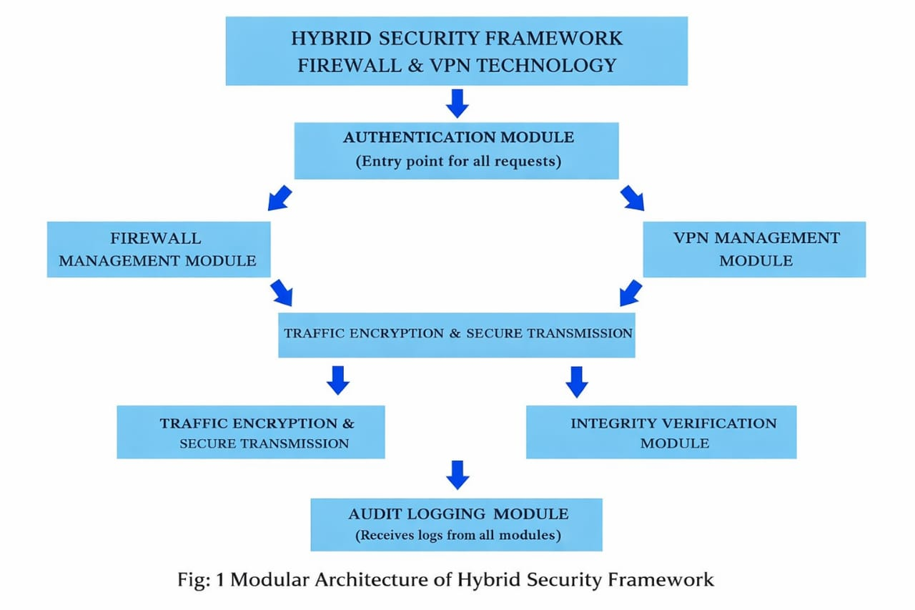
Fig :1 Modular Architecture

- Authentication & Access Control Module → Validates users and devices before granting network access

- Firewall Policy Management Module → Filters and controls incoming and outgoing network traffic

- VPN Tunnel Management Module → Establishes secure encrypted tunnels for remote communication

- Traffic Encryption & Secure Transmission Module → Protects data confidentiality during transmission

- Integrity Verification Module → Ensures data packets are not modified in transit

- Audit Logging & Monitoring Module → Records logs from all modules for analysis and compliance

3.6.2 CODE DOCUMENTATION

All firewall rules, VPN configurations, scripts, and automation files are properly documented using inline comments and configuration annotations. Clear documentation ensures better understanding, easy modification, reusability, and smooth future enhancements. This approach reduces configuration errors and simplifies maintenance for system administrators.

3.7 VERSION CONTROL
Version control is implemented using Git to manage firewall rules, VPN configurations, scripts, and related documentation. It ensures controlled updates, collaboration, and preservation of system integrity.

Importance of Version Control

1. Traceability

Traceability enables tracking of every change made to firewall and VPN configurations, including who made the change, when it was made, and the reason for the modification.

2. Collaboration

Version control allows multiple administrators or developers to work simultaneously on different components of the hybrid security framework without interfering with each other’s work.

3. Roll back and Recovery

In the event of misconfiguration, system failure, or security issues, Git enables quick rollback to a previously stable firewall or VPN configuration.

3.8 SYSTEM PERFORMANCE AND EFFICIENCY
The system employs efficient firewall filtering mechanisms and secure VPN encryption protocols to protect network communication. VPN technologies such as WireGuard or OpenVPN use modern cryptographic algorithms that provide strong security while maintaining high performance.
Optimized firewall rule sets and lightweight encryption ensure minimal processing overhead and low latency. This balance enables secure data transmission and effective threat protection without significantly impacting network speed or system responsiveness.

CHAPTER 4
SYSTEM DESIGN

1.1 DESIGN OVERVIEW

The system design of the Hybrid Security Framework integrating Firewall and VPN Technology focuses on providing a secure, scalable, and efficient network protection mechanism for modern computing environments. The design combines firewall-based traffic filtering with VPN-based encrypted communication to ensure confidentiality, integrity, and controlled access to network resources.
The system follows a client–server network architecture, where firewall services operate at the network perimeter and VPN services provide secure remote connectivity. Authorized users and devices can securely access internal network resources through encrypted VPN tunnels while the firewall enforces strict access control policies.
The design enables administrators to configure firewall rules, manage VPN connections, monitor network traffic, and maintain detailed logs for auditing and security analysis. All network activities are recorded to ensure accountability, compliance, and traceability.
Key design principles include:
• Security-first network architecture
• Role-based access control
• Modular and maintainable system design
• Continuous monitoring and auditability

1. CORE PHILOSOPHY

Security:
Security is the primary objective of the hybrid framework. The system protects network resources by filtering malicious traffic through firewall rules and securing data transmission using VPN encryption. Only authenticated and authorized users are permitted to establish VPN connections or access protected network services.
Integrity:
To ensure data integrity, encrypted VPN tunnels protect network traffic from interception or tampering during transmission. Firewall inspection and packet validation mechanisms help detect malformed or suspicious packets, ensuring reliable and secure communication.
Accessibility:
The framework provides controlled accessibility through VPN-based remote access. Authorized users can securely connect to the internal network from remote locations without exposing internal services directly to the public internet.
Accountability:
All network activities—including firewall rule enforcement, VPN connection attempts, successful logins, and security alerts—are logged with timestamps, source IP addresses, and user identifiers. This ensures transparency, traceability, and effective incident response.

1.2 ARCHITECTURAL DIAGRAM
Frontend Component: User & Admin Interface
The frontend component provides an intuitive interface for administrators and authorized users to interact with the firewall and VPN system
Functions:
• User and administrator login
• Role-based access control
• Firewall rule configuration and management
• VPN connection initiation and termination
• Monitoring firewall and VPN status

Backend Component: Firewall & VPN Processing Engine
The backend component handles core security operations and policy enforcement.
Functions:
• Processing authentication and authorization requests
• Enforcing firewall rules and traffic filtering
• Managing VPN tunnels and encryption
• Handling secure communication between components
• Generating system and security logs
Database Component: Configuration & Log Storage
• SQLite(development/testing)
• PostgreSQL / MySQL (production – optional)

The database design ensures consistency, traceability, and efficient retrieval of security-related data.
Firewall Component: Traffic Filtering & Access Control
The firewall component acts as the first line of defense for the network.
Functions:
• Blocking unauthorized IP addresses and ports
• Preventing common network attacks
• Enforcing access control policies
VPN Component: Secure Communication & Encryption
The VPN component ensures secure remote connectivity.
Functions:
• Establishing encrypted VPN tunnels
• Secure transmission of data over public networks
• Authenticating remote users and devices
• Maintaining confidentiality and integrity of data
Technologies Used:
• WireGuard / OpenVPN
• OpenSSL / built-in cryptographic libraries

Security & Monitoring Component
This component ensures continuous monitoring and auditing of the system.
Functions:
• Logging firewall and VPN activities
• Detecting suspicious behavior
• Supporting incident investigation
• Ensuring compliance and accountability

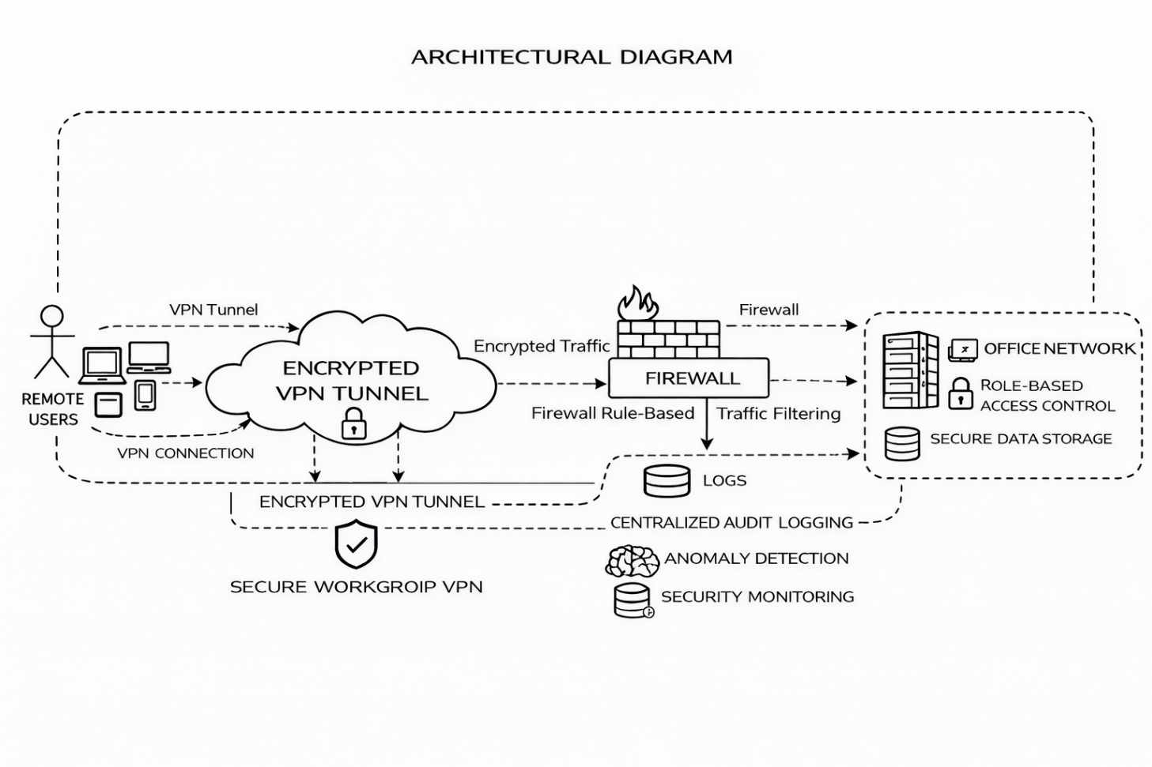

Fig: 2 Architectural Diagram

Responsibilities:
Component | Responsibility
Frontend | User and admin interaction
Backend | Policy enforcement and processing
Database | Secure storage of configurations and logs
Firewall | Traffic filtering and access control
VPN Module | Encrypted communication
Monitoring Module | Logging and security analysis

1.3 UML OVERVIEW
Unified Modeling Language (UML) diagrams are used to visually represent the structure and behavior of the hybrid firewall and VPN system. UML helps in understanding system interactions, roles, and security workflows.
Use Case Diagram
Actors:
• Administrator
• Authorized User
Use Cases:
• Login / Authentication
• Configure Firewall Rules
• Establish VPN Connection
• Monitor Network Traffic
• View Logs and Alerts
• Disconnect VPN
• Manage Security Policies

UML diagrams provide a clear and standardized way to communicate system design and security interactions among developers, administrators, and stakeholders.
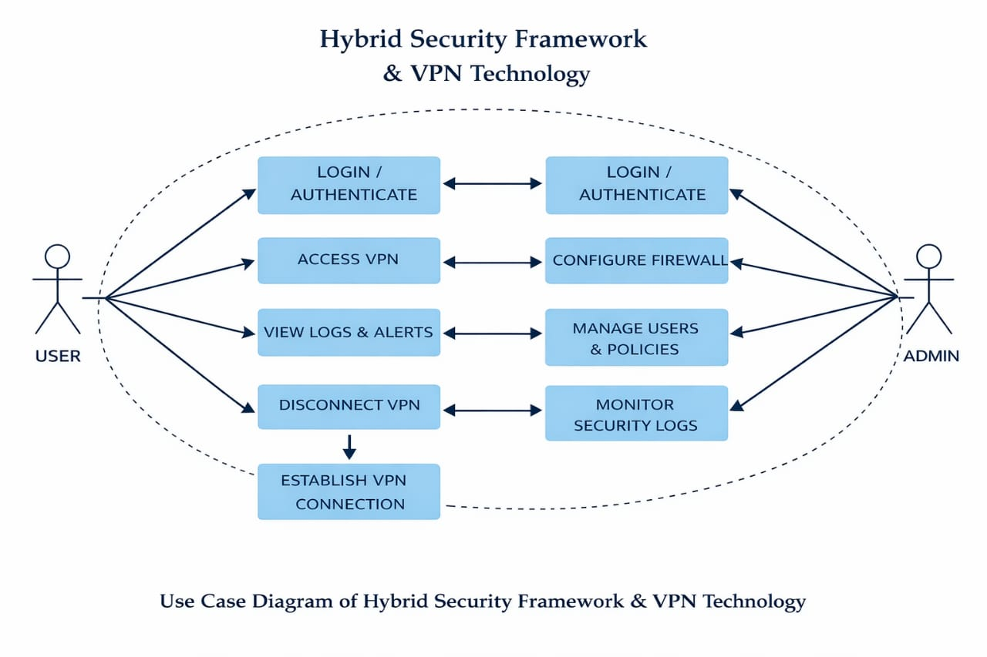
Fig: 3 UML Diagram

1.4 COMPONENT OVERVIEW
Frontend Component – User Interface

The frontend component provides a secure and interactive web-based interface developed using HTML, CSS, and JavaScript. It enables administrators and users to authenticate, configure firewall rules, initiate VPN connections, monitor network traffic, and view security alerts.Backend Component –Flask Logic & Security

The backend component is developed using Python with the Flask framework, which acts as the core controller of the hybrid security framework. It manages communication between the firewall and VPN modules while enforcing security policies.
- User authentication and role-based access control
- Firewall rule configuration and traffic filtering logic
- VPN tunnel creation, authentication, and session handling
- Secure API communication between frontend and network services
- Logging and monitoring of security events

Firewall Component – Network Traffic Filtering

The firewall component is responsible for inspecting, filtering, and controlling inbound and outbound network traffic based on predefined security rules.
It protects the system from unauthorized access, malicious traffic, and network-based attacks.

VPN Component – Secure Communication Channel

The VPN component establishes encrypted tunnels to ensure secure data transmission over untrusted networks.
It provides confidentiality and privacy by masking internal network details and encrypting all communication between clients and servers.
Database Component – Configuration & Log Storage

The database component stores structured data related to:
- User credentials and access roles
- Firewall rules and configurations
- VPN session details
- Network traffic logs and security alerts
A relational database system is used to maintain data integrity, enforce constraints, and support audit and forensic analysis.

Security Component – Encryption, Authentication & Integrity
This component strengthens the hybrid security framework by implementing cryptographic and authentication mechanisms.
It ensures:
- AES encryption for securing VPN data transmission
- SHA-256 hashing for integrity verification of configuration files and logs
- Secure credential storage and authentication
- Session validation and access control enforcement\

Together, these mechanisms protect the system against data breaches, unauthorized access, and tampering.

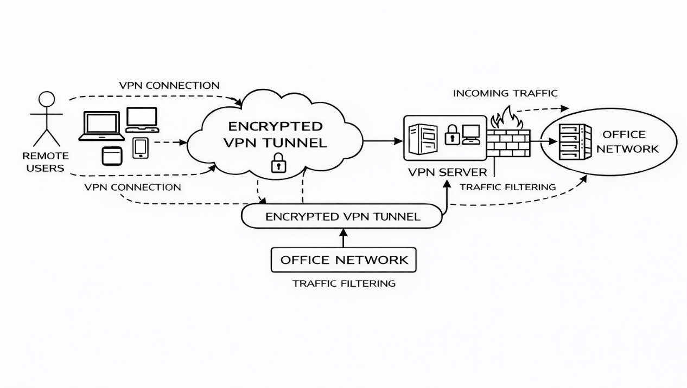

Fig: 4 Component Diagram

1.5 SYSTEM LEVEL DIAGRAM
At the system level, the Hybrid Security Framework integrating Firewall and VPN Technology consists of the following major components:
1.User / Investigator
The user or network client accesses internal resources either from within the local network or from a remote location using a secure VPN connection.
2. VPN Gateway
The VPN gateway authenticates users and establishes an encrypted tunnel between the client and the internal network, ensuring secure data transmission over public or untrusted networks.
3. Firewall System
The firewall acts as the primary security control point, monitoring, filtering, and controlling incoming and outgoing network traffic based on predefined security rules and policies.
4.Protected Internal Network / Server
This component includes internal servers, applications, and resources that are accessible only to authorized users through the firewall and VPN.
5. Security & Logging Layer
This layer maintains logs of firewall activities, VPN connections, authentication attempts, and detected threats for auditing, monitoring, and forensic analysis.
Data Flow:
VPN Authentication & Tunnel Establishment → Encrypted Traffic Transmission→ Firewall Rule Inspection & Filtering→ Access to Internal Network Resources → Security Monitoring & Audit

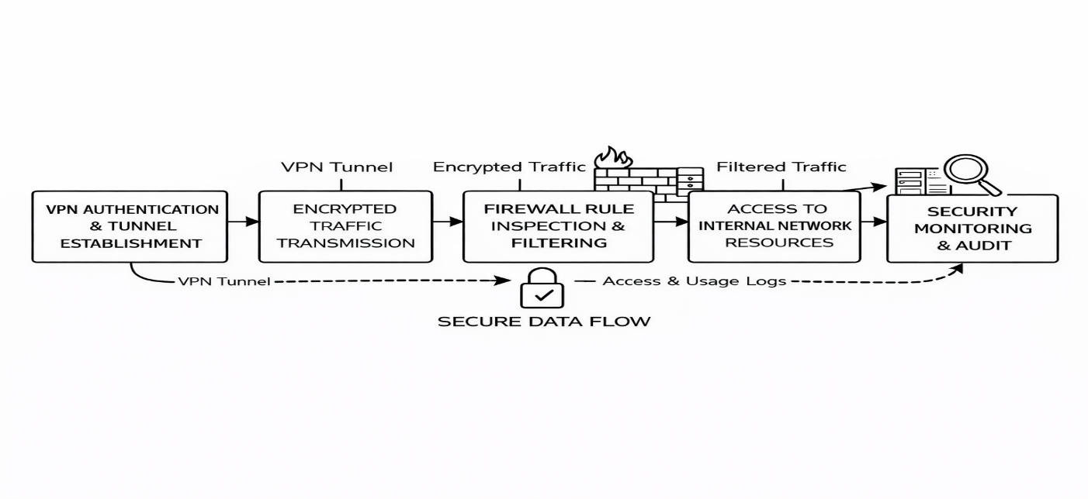

Fig: 5 System Level Diagram

CHAPTER 5
MODULE DESCRIPTION

This chapter describes the functional modules of the proposed Hybrid Security Framework integrating Firewall and VPN Technology. Each module is designed to perform a specific security function while collectively ensuring secure network access, data confidentiality, integrity, and controlled communication. The modular design improves system maintainability, scalability, and security enforcement.
5.1 OVERVIEW OF SYSTEM MODULES
The Hybrid Security Framework is divided into the following major modules:

- User Authentication and Access Control Module
- Administrator Management Module
- Firewall Configuration and Rule Management Module
- VPN Connection and Tunnel Management Module
- Secure Data Transmission Module
- Traffic Monitoring and Integrity Validation Module
- Remote Access Management Module
- Audit Logging and Reporting Module
Each module operates independently but interacts securely through the central network security controller.

User Registration and Authentication Module

This module manages secure user access to the network.
Functions
- User login with credentials
- Role-based access control (User / Admin)
- VPN authentication validation
- Session management and timeout control

Purpose
This module ensures that only authorized users and devices can access the protected network resources.

Administrator Management Module

This module allows administrators to monitor and manage network security.
Functions
- Administrator login and authentication
- Manage user accounts and permissions
- Configure security policies
- Monitor firewall and VPN activities
Purpose
Ensures centralized control, policy enforcement, and system oversight.

5.4 FIREWALL CONFIGURATION AND RULE MANAGEMENT MODULE

This module controls incoming and outgoing network traffic.

Functions
- Define firewall rules and access policies
- Filter packets based on IP, port, and protocol
- Block unauthorized or malicious traffic
- Allow legitimate network communication

Purpose
Protects the internal network from unauthorized access, intrusions, and attacks.

5.5 VPN CONNECTION AND TUNNEL MANAGEMENT MODULE

This module establishes secure VPN tunnels for remote access.

Functions

VPN client authentication

Encrypted tunnel establishment

Key exchange and session handling

Secure disconnection management

Purpose
Ensures confidential and secure communication over public or untrusted networks.
5.6 SECURE DATA TRANSMISSION MODULE
This module protects data during transmission.
Functions
- Encrypt network traffic using VPN protocols
- Prevent data interception and eavesdropping
- Maintain confidentiality and integrity
Purpose
Protects sensitive data from man-in-the-middle attacks and packet sniffing.
5.7 TRAFFIC MONITORING AND INTEGRITY VALIDATION MODULE
This module monitors network behavior and detects anomalies.
Functions
- Inspect network packets
- Detect suspicious or abnormal traffic
- Validate data integrity
- Generate security alerts
Purpose
Maintains network integrity and detects potential security threats.
5.8 REMOTE ACCESS MANAGEMENT MODULE
This module manages secure access from remote locations.
Functions
- Authenticate remote users
- Control access to internal resources
- Enforce firewall and VPN policies
- Terminate unauthorized sessions
Purpose
Provides secure and controlled remote connectivity without exposing internal systems.

5.9 AUDIT LOGGING AND REPORTING MODULE
This module records all system activities.
Functions
- Log firewall rule actions
- Record VPN connection attempts
- Track user access and session activity
- Generate security reports
Purpose
Ensures accountability, traceability, and forensic readiness.

5.2 OVER ALL SYSTEM FLOWALGORITHM
- User attempts to access the network.
- System authenticates the user credentials.
- VPN authentication is initiated.
- Secure VPN tunnel is established.
- Firewall validates traffic against defined rules.
- Encrypted data transmission begins.
- Network traffic is continuously monitored.
- Unauthorized traffic is blocked by the firewall.
- All activities are logged in the audit system.
- User accesses permitted internal resources.
- Session is terminated upon logout or timeout.
- Logs are stored for analysis and reporting.

CHAPTER 6
CONCLUSION AND FUTURE WORK

[1] CONCLUSION

The Hybrid Security Framework integrating Firewall and VPN Technologies effectively addresses the critical security challenges present in modern network environments, such as unauthorized access, data interception, insecure remote connectivity, and insufficient monitoring mechanisms. With the increasing dependence on networked systems and remote access, ensuring confidentiality, integrity, and availability of network resources has become a fundamental requirement.
This project presents a robust security solution by combining firewall-based traffic filtering with VPN-based encrypted communication. The firewall component enforces strict access control policies by monitoring and filtering incoming and outgoing traffic, thereby preventing unauthorized access and network-based attacks. The VPN component ensures secure remote access by establishing encrypted tunnels over public or untrusted networks, protecting data from eavesdropping and man-in-the-middle attacks.
The framework further strengthens network security through user authentication, role-based access control, and comprehensive audit logging, ensuring that every connection attempt and network activity is traceable. Detailed logs enhance accountability and provide valuable insights for incident response and forensic analysis.
The modular architecture of the system improves scalability, maintainability, and flexibility, allowing future enhancements without major redesign. Overall, this project demonstrates how the integration of firewall and VPN technologies can provide a secure, reliable, and efficient hybrid network security solution, suitable for both academic study and real-world enterprise environments.
[2] WORKS TO BE DONE IN PHASE II

- Completion of Advanced Security Modules

• Some advanced firewall rule optimization and VPN management features are partially implemented.
Phase II will focus on completing and refining:
- Dynamic firewall rule management
- Advanced VPN tunnel optimization
- Automated threat detection mechanisms

- Implementation of Full Administrator Privileges

- Development of a dedicated administrator dashboard with enhanced controls.
- Admin capabilities will include:
- User approval, suspension, and role assignment
- Firewall rule creation and modification
- VPN user and session management
- Review of detailed security and access logs

3. Enhanced Role-Based Access Control

• Implementation of granular access permissions for different user roles.

• Separation of privileges for:
  - Network administrators
  - Regular users
  - Remote access users

• Prevention of unauthorized policy changes and configuration misuse.

4. Performance Optimization
- Optimize firewall packet inspection for high traffic volumes.
- Improve VPN encryption and decryption efficiency.
- Reduce latency in secure remote connections.
- Enhance log processing and storage performance.

5. Advanced Security Enhancements
- Integration of multi-factor authentication for administrative access.
- Implementation of intrusion detection and alerting mechanisms.
- Secure session timeout and automatic disconnection for inactive VPN sessions.
- Real-time monitoring dashboards for threat visualization.

6. Cloud and Scalability Support
- Integration with cloud-based firewall and VPN services.
- Support for hybrid cloud and on-premise environments.
- Scalability to handle large numbers of users and distributed networks.

[3] SUMMARY
Phase I of the Hybrid Security Framework project focuses on system design, architectural validation, and implementation of core firewall and VPN security mechanisms. Although some advanced administrative features and optimizations remain under development, the project establishes a strong foundation for secure network access and communication.

Phase II will build upon this foundation by completing unfinished modules, introducing advanced administrative controls, optimizing system performance, and enhancing overall security capabilities. Once fully implemented, the system has the potential to serve as a scalable, enterprise-ready, and resilient network security solution, capable of protecting modern digital infrastructures from evolving cyber threats.
REFERENCES
30
- R. S. Tahilramani, “Secure Data Storage using AES Encryption”, International Journal of Computer Applications, https://www.ijcaonline.org
- A. K. Jain, “Hash Functions and Data Integrity in Network Security”, IEEE, https://ieeexplore.ieee.org
- W. Stallings, Cryptography and Network Security: Principles and Practice, Pearson Education, 2017
🔗 https://www.pearson.com/en-us/subject-catalog/p/cryptography-and-network-security/P200000003350
- NIST (National Institute of Standards and Technology), Guide to Firewalls and VPN Security, Special Publication SP 800-41, 2021
🔗 https://nvlpubs.nist.gov/nistpubs/SpecialPublications/NIST.SP.800-41r1.pdf
- NIST, Guide to Integrating Forensic Techniques into Incident Response, SP 800-86
🔗 https://nvlpubs.nist.gov/nistpubs/Legacy/SP/nistspecialpublication800-86.pdf
- D. Eastlake and P. Jones, Secure Hash Standard (SHA-2), NIST FIPS 180-4, 2015
🔗 https://nvlpubs.nist.gov/nistpubs/FIPS/NIST.FIPS.180-4.pdf
- OpenSSL Documentation — Encryption and VPN Security Implementation
🔗 https://www.openssl.org/docs/
- Cisco Systems, Firewall and VPN Design Guidelines, 2020
🔗 https://www.cisco.com/c/en/us/products/security/firewalls/index.html
- Al-Khateeb, H., Epiphaniou, G., “Data Integrity and Secure Communication using Cryptographic Hash Functions”, Journal of Information Security, 2019
🔗 https://www.scirp.org/journal/paperinformation.aspx?paperid=94409
- OpenVPN Documentation — Secure VPN Setup and Configuration
🔗 https://openvpn.net/community-resources/
- GitHub – WireGuard VPN Implementation in Python
Repository demonstrating secure VPN tunneling and connection management
🔗 https://github.com/WireGuard
- Django Official Documentation — User Authentication and Role-Based Access Control
🔗 https://docs.djangoproject.com
- PyCryptodome Library Guide — AES Encryption and Cryptographic Functions
🔗 https://pycryptodome.readthedocs.io

